Introduction of Equipment stored in Jakarta base

1. Hi Sprint 1500 (Vikoma, UK)
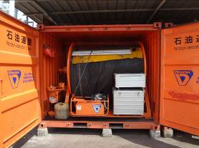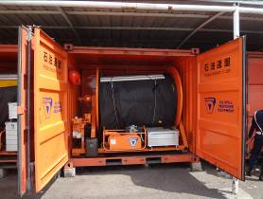
No.1 No.2
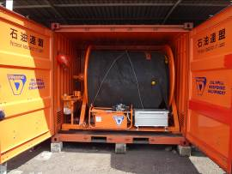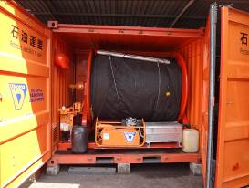
No.3 No.4

Hi sprint1500 is single-point Inflatable flotation boom.
Freeboard: 60 cm
Draft: 90 cm
Length: 250 m/set
Weight: 4.6ton
Boom, powerpack, hose and other accessories are in the 10ft container.

Introduction of Equipment stored in Jakarta base

2. GT185-6 (LAMOR, Finland)
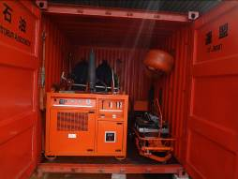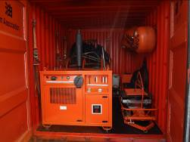
No.1 No.2
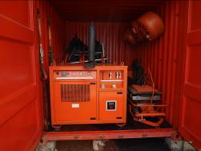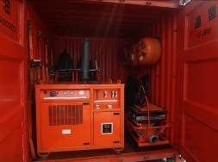
No.3 No.4

GT185-6 is very simple weir skimmer.
Recovering capacity: 50 kl/h
Weight: 2.8ton
Skimmer, powerpack, hose and other accessories are stored in 10ft container.

Introduction of Equipment stored in Jakarta base

3. FASTANK (Fast Engineering, UK)
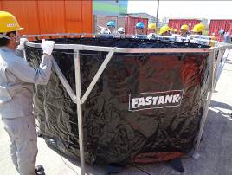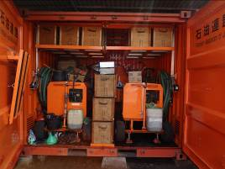
Reference image Storage condition (Inside of Beach cleaner container)
Temporary oil storage tank
Size of tank: 3.2 m in diameter, 1.5 m high
Capacity 9ton
Size of wooden box: 1.6 mL × 0.4 mW × 0.4 mH
Net weight: 72 kg
*Each tank is stored in the wooden box (total 8 tanks in the 8 boxes)
PAJ will transfer only tanks with wooden boxes as “Disposal number 1-109”.
*The storage condition in the above picture has been changed due to some operational reason so please ask PAJ for the current detail of the storage condition.

4. Beach Cleaner (Vikoma, UK)
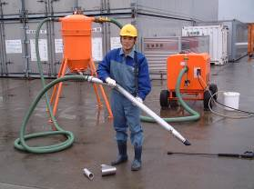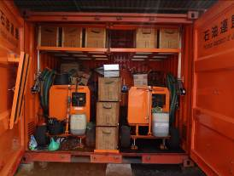
Reference image Storage condition (No.1 & No.2)
Beach cleaner is designed for the removal of oiled sands, muds and debris up to a rate of 30 tonnes per hour. The high-pressure water jet can use salt or freshwater.
*Beach cleaner (2set) are stored in one container but the container will not be included in the tender (We will be able to transfer beach cleaner without container).

